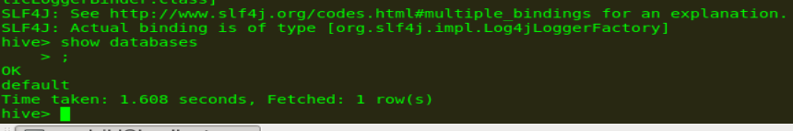

Create database named custom.



Use database custom



Create table

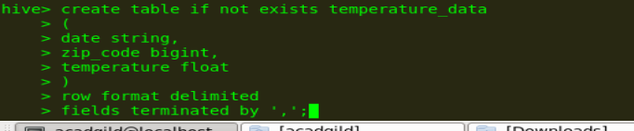

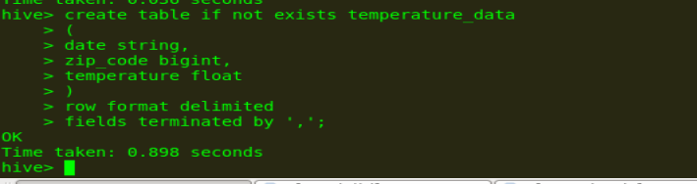



Loading data



